2025

Rhea Jugernath, Erin Naidoo, Shiara Phekoo, Chloe Naidoo

404 Soltions

20/03/2025

404 Solutions -Part 1 - Research

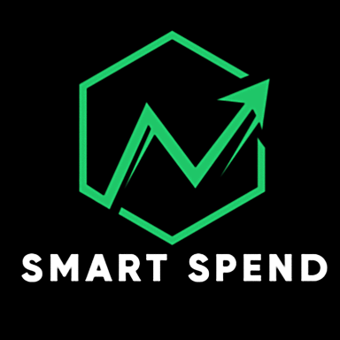

**Part 1 – Prog7313_POE**

**Introduction**

Managing personal finances can be challenging, especially when balancing daily expenses, savings goals, and unexpected costs. Many people find budgeting overwhelming, not because they lack financial discipline, but because keeping track of every expense can feel like a tedious task (Standard Bank, N/a). This is where budgeting apps come in—they simplify the process, helping users track their spending, plan ahead, and make informed financial decisions. However, not all budgeting apps are equally effective, and the right one depends on individual needs and preferences (Pitchlabs, 2024).

This research explores three widely used budgeting apps for Android: Goodbudget, Monefy, and PocketGuard. Each app takes a unique approach to financial management, offering different tools and strategies to help users stay on top of their finances. By analyzing their features, strengths, and limitations, we aim to identify what makes a budgeting app effective and engaging.

This research forms part of the planning and design phase for developing our own personal budgeting app. Our goal is to learn from existing solutions, determine which features contribute to a positive user experience, and explore ways to make financial tracking more intuitive, visually engaging, and even rewarding (Eleken, 2024). Since many people find managing finances stressful, it is important to design an app that not only provides useful tools but also encourages consistent use through a well-thought-out interface and possibly even gamification elements.

By the end of this study, we will have a clearer understanding of the key components needed to build an effective budgeting app—one that helps users take control of their finances with confidence and ease.

**Research on Goodbudget**

**Overview:**

Goodbudget is a budgeting app available on both Google Play and the iOS App Store, making it accessible to a wide range of users. Recognized as one of the top budgeting apps by sources like CNBC, NerdWallet, and Old Mutual, it has an average rating of 4.6 stars, with mostly positive reviews. The app is lightweight (80MB) and requires an internet connection to function (Goodbudget, N/A).

**Aesthetic & User Interface :**

Goodbudget features a green color scheme that aligns with its financial focus. Its clean and professional design ensures a simple and pleasant user experience. Users can switch between light and dark mode, and the app is ad-free, except for its Goodbudget Plus subscription promotions.

**Using the app : (screenshots with descriptions)**

When launching the app, users are greeted with a welcome page where they can log in or create a new household. First-time users must set up a household before proceeding to manage their budget and finances (Goodbudget, N/A).

After selecting ‘Create New Household’, I was directed to the ‘Set Up Budget’ screen. Expenses are categorized under headings like ‘Food’, ‘Other’, ‘Savings’, ‘Utilities’, ‘Auto’, and ‘Bills’, with each monthly cost displayed on the right. The total budget amount is shown in green at the bottom right. Users can adjust the budget period (monthly, weekly, semi-monthly, or bi-weekly) and set the reset date by tapping ‘Monthly’. Each expense is referred to as an envelope in the bottom left corner (Goodbudget, N/A).

On this screen, we add an expense/envelope by entering details like the name, amount, category, and payment frequency. After tapping ‘Save’, the expense is added to the list on the ‘Set Up Budget’ page. We repeat this process for all our expenses (Goodbudget, N/A).

Tapping ‘Next’ on the top right, the app notifies me that my budget is set and I need to fill my envelopes to start spending. I had the option to fill them manually or let the app do it for me. I chose to let the app automatically fill the envelopes (Goodbudget, N/A).

These are our filled envelopes, which allocate money to each of my monthly expenses.

Each time an envelope is filled or emptied, it’s logged on the transaction page, showing the fill details and the next scheduled fill. Tapping on the next scheduled fill directs us to a screen where we can edit our income amount and allocate it to the envelopes (Goodbudget, N/A).

Users manually log each payment under "My Account," which is a default account not linked to a bank. Transactions must be recorded with the correct details to reflect on the envelopes dashboard. (Goodbudget, N/A)

The Accounts page displays all user accounts and their balances. Users can add, delete, rename, or adjust balances as needed. (Goodbudget, N/A)

The Reports page provides graphs that visually represent spending, income trends, and debt progression based on envelope usage. (Goodbudget, N/A)

Users can upgrade to Goodbudget Plus to unlock additional features and premium functionality. (Goodbudget, N/A)

**Strengths**

* The app runs smoothly without bugs, crashes, or errors. (ExpertPanel, 2021)
* It is easy to use and understand. (ExpertPanel, 2021)
* Highly customizable, allowing users to edit expenses, income, and accounts. (ExpertPanel, 2021)
* Effectively fulfills its purpose as a budgeting tool. (ExpertPanel, 2021)

**Weaknesses**

* Lacks instructions or a tutorial, which may make it confusing for new users. (ExpertPanel, 2021)
* Limited functionality unless users pay for the premium version. (ExpertPanel, 2021)

**Innovative Features**

* Generates expense reports to help users track spending trends. (Goodbudget, N/A)
* Offers detailed customization, making it adaptable to different user needs. (Goodbudget, N/A)

**Research on Monefy:**

**Overview:**

Monefy is a personal finance management app designed to simplify expense tracking and budgeting. Available on Android, iOS, and Windows Phone, it provides an intuitive interface for monitoring financial activities and improving spending habits (Monefy, N/a).

Users can manually record expenses and income, categorizing them into predefined or custom categories. The app visualizes financial data through charts and summaries, allowing users to track spending over different periods (daily, weekly, monthly, or annually). Key features include multi-currency support, data synchronization via Google Drive or Dropbox, passcode protection, and multi-account management(Monefy, N/a).

**Using the app: (screenshots with descriptions)**

The homepage allows users to enter budget amounts for each expense category, helping them set and manage their financial allocations efficiently. This feature supports organizing budgets by specifying amounts for each category(Monefy, N/a).

The Categories dropdown lets users select from available categories, with the option to add new categories or remove existing ones, offering dynamic control over the list (Monefy, N/a).

The Right Drop-down menu displays various features of the app, providing easy access to different functionalities within the application (Monefy, N/a).

The Transfers page allows users to manage transfers, with features to input transfer values and add notes, providing full control over transfer actions (Monefy, N/a).

The Left Drop-down menu allows users to select the duration for which the app will create the budget, providing flexibility in budget planning (Monefy, N/a).

The Accounts Drop-down menu allows users to add accounts and manage transfers, offering control over their account-related actions (Monefy, N/a).

The Settings Drop-down menu lets users customize the app’s features, allowing them to adjust settings according to their preferences (Monefy, N/a).

**Strengths**

* Monefy’s intuitive design makes expense tracking quick and easy (Unitq, 2024).
* Clear charts help users visualize their spending (Unitq, 2024).
* Users can customize expense categories for flexibility (Unitq, 2024).
* Monefy supports multiple currencies for global use.
* Passcode protection ensures data privacy.
* Data syncs across devices via Google Drive or Dropbox.
* The free version is ad-free for an uninterrupted experience (Unitq, 2024).

**Weaknesses**

* Users must manually input transactions, which can be time-consuming and prone to errors.
* The app lacks detailed budgeting tools, limiting its use for comprehensive financial planning.
* Currency change feature is only available with a subscription (Unitq, 2024).
* Some users experience syncing issues, leading to data inconsistencies.
* Exchange rates must be manually updated, adding extra work for users.
* Basic reporting features are offered, but advanced analysis tools are missing.
* Monefy lacks a web interface, limiting access to mobile devices only.
* Some users find the premium subscription costly for the features provided (Unitq, 2024).

**Innovative Features**

* Monefy lets users quickly add expenses by tapping category icons on the main screen, streamlining data entry (appshunter, N/a).
* Users can personalize expense categories and icons to suit their financial tracking needs.
* Data syncs through Google Drive or Dropbox, ensuring secure backup and access across devices (apsshunter, N/a).
* Monefy is a simple, customizable budgeting app, ideal for personal finance management, but lacks advanced automation and budgeting features.

**Research on PocketGuard**

**Overview**

PocketGuard is a financial management app that tracks income, expenses, and savings by linking to bank accounts, categorizing transactions, and calculating disposable income. Its "In My Pocket" feature estimates safe-to-spend amounts after essentials and savings( PocketGuard, 2024). Available on iOS and Android, it offers a free version with basic features, while PocketGuard Plus (paid) includes custom categories, transaction exports, and bill negotiation. It aims to simplify budgeting and help users make informed financial decisions (Investopedia, 2024).

**Using the app: (screenshots with descriptions)**

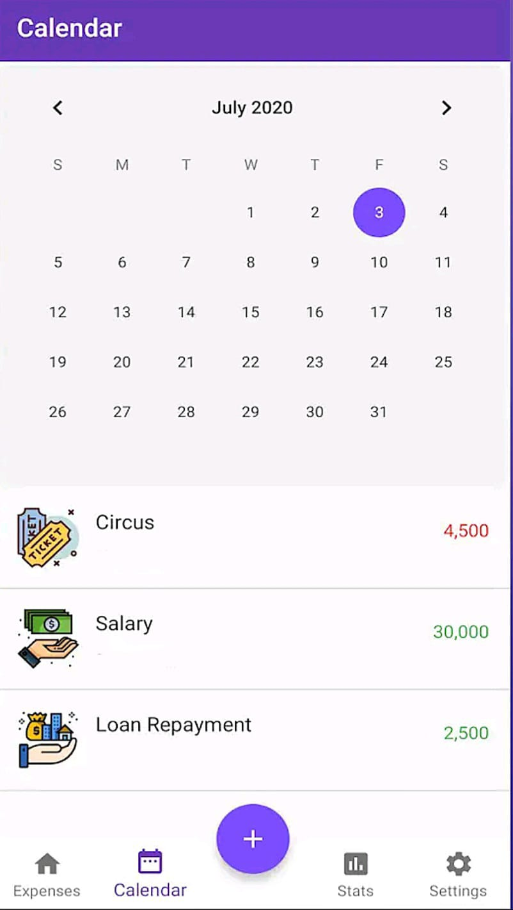

Main Dashboard: Displays an overview of financial activity, including income, expenses on a calendar. (PocketGuard, 2024).

"In My Pocket" Calculation: Calculates total income and total expenses for the month, as well as displays balance fo rthe month. (PocketGuard, 2024).

Transaction Categorization: Automatically sorts spending into predefined categories such as food, utilities, and entertainment. Keeps track of each transaction. (PocketGuard, 2024).

Spending Analysis: Provides visual charts to highlight spending trends and potential savings opportunities. (PocketGuard, 2024).

**Strengths:**

* Automated Budgeting: Links to bank accounts, categorizes transactions, and minimizes manual input. (Forbes, 2023).
* User-Friendly Interface: Easy to navigate, even for those with limited financial experience.
* Real-Time Spending Insights: "In My Pocket" shows available discretionary funds. (PocketGuard, 2024).
* Bill Management & Alerts: Tracks due bills and sends notifications to prevent overdrafts.
* Strong Security: Uses bank-level encryption, multi-factor authentication, and secure login.
* Debt Reduction Planning: Offers strategies for managing and repaying debt. (CNBC, 2023).

**Weaknesses**

* Restricted Free Version: Limited customization encourages upgrading to a paid plan.
* Bank Connectivity Issues: Some users face syncing challenges. (PocketGuard, 2024).
* Learning Curve: Automated insights may overwhelm beginners. (CNBC, 2023).
* No Investment Tracking: Lacks portfolio management features.
* Limited Cash Support: Requires manual entry for cash transactions. (PocketGuard, 2024).

**Innovative Features**

* In My Pocket" Algorithm: Calculates real-time spendable income after essentials. (PocketGuard, 2024).
* Bill Reduction Assistance: Helps negotiate lower utility and subscription costs. (Investopedia, 2024).
* Automated Savings: Smart Save suggests transfers based on spending patterns.
* AI Expense Analysis: Uses AI to assess habits and suggest budget improvements. (PocketGuard, 2024).
* Subscription Management: Tracks and helps cancel recurring payments. (Investopedia, 2024).
* Goal-Oriented Budgeting: Provides personalized savings strategies.

**Best features of all the apps:**

1. Easy & Intuitive Interface

• Effortless expense tracking: The app makes it easy to quickly enter expenses, so users don't feel overwhelmed by the process. A simple design means users are more likely to stay engaged and consistently track their spending.

• Spending insights at a glance: With clear charts and graphs, users can easily see where their money is going. This helps them make informed decisions and stick to their budget without much effort.

2. Envelope Budgeting System

• Organizing your money: By setting aside specific amounts for different categories (like groceries, entertainment, etc.), this feature encourages responsible spending. It helps users manage their budget by creating a clear structure for their finances, reducing the temptation to overspend.

3. Goal-Based Savings

• Track your financial goals: Whether saving for a vacation, a new gadget, or an emergency fund, this feature allows users to break down their big dreams into smaller, manageable targets. Seeing progress along the way keeps them motivated and on track to hit their financial goals.

4. Bill Tracking

• Never miss a bill again: With reminders for upcoming bills, this feature helps users avoid late payments and the penalties that come with them. Staying on top of bills also protects their credit score and keeps their finances in good shape.

5. Multi-Currency Support

• Manage expenses in any currency: Perfect for travellers or people working with international clients, this feature makes it easy to track spending in multiple currencies. It takes the guesswork out of conversions and provides a more accurate picture of your overall financial situation.

**Infographic comparison: Canva (2025)**

<https://www.canva.com/design/DAGhDUuwbWw/6MjE84wCcvmEuxNrNLH0Jg/edit?utm_content=DAGhDUuwbWw&utm_campaign=designshare&utm_medium=link2&utm_source=sharebutton>

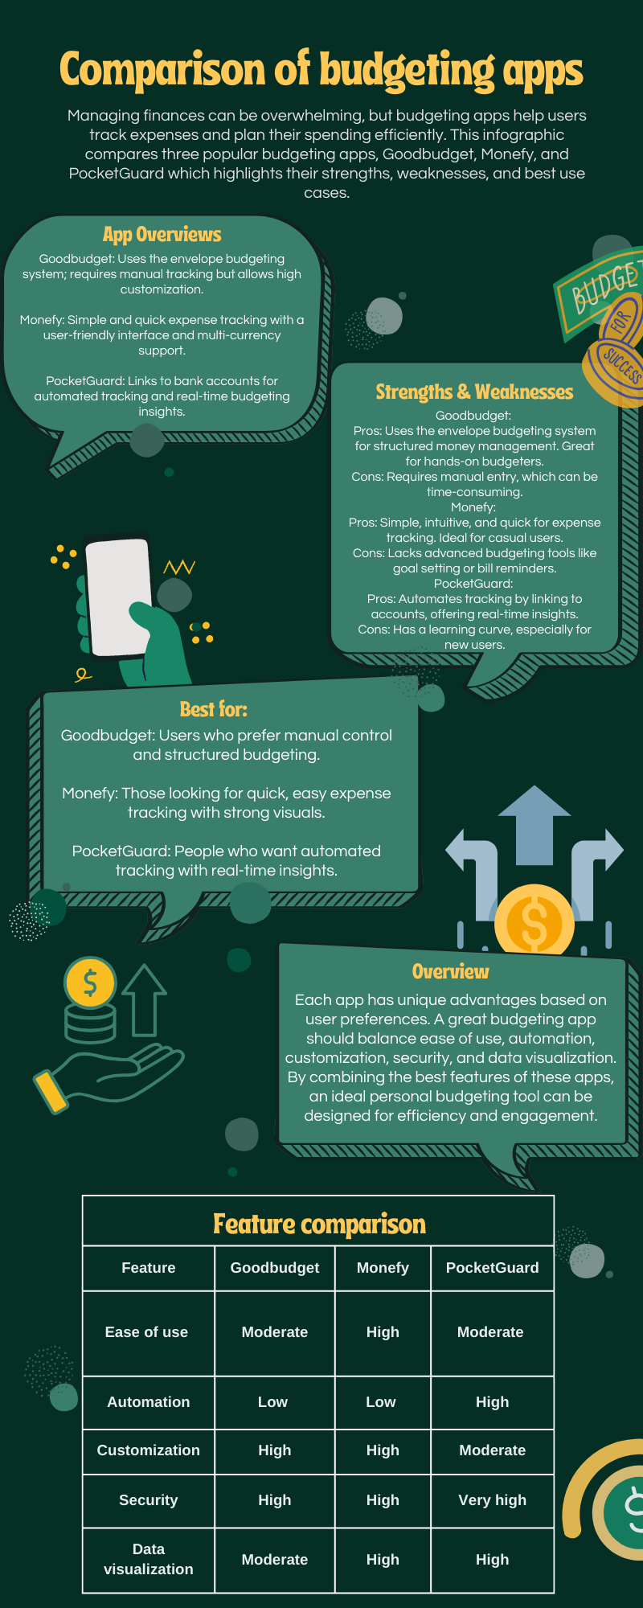

**Best features of all the apps:**

1. Easy & Intuitive Interface:

* Simple and quick expense entry
* Visual charts and graphs for spending insights

1. Envelope Budgeting System:

* Pre-allocate funds for specific spending categories which helps users stick to a structured budget

1. Goal-Based Savings Feature:

* Helps users set financial goals and track progress

1. Bill Tracking:

* Sends reminders to avoid late payments

1. Multi-Currency Support:

* Allows users to track expenses in different currencies

**Conclusion**

Budgeting apps are essential tools for effectively managing personal finances, allowing users to track costs, set savings goals, and plan for the future. This infographic compares three popular budgeting apps: Goodbudget, Monefy, and PocketGuard, highlighting their pros and weaknesses.

Goodbudget is a typical envelope budgeting technique that is suitable for those who value structured financial planning. While it offers outstanding customization and extensive reporting, the free edition lacks a tutorial and has limits that may make it difficult for novices.

Monefy is noted for its simplicity and speed, as well as its user-friendly design and compatibility for multiple currencies. However, its reliance on manual data entry and lack of advanced budgeting capabilities may restrict its utility for those that require more thorough financial management.

PocketGuard excels at automation, syncing with bank accounts and tracking real-time transactions. Its outstanding feature, "In My Pocket," gives consumers an immediate snapshot of their spending money. While it provides essential tools such as bill management and AI-powered analysis, network challenges, a learning curve, and limits in the free edition may limit accessibility.

By combining the best features of these apps, intuitive interfaces, bank account sync, real-time tracking, envelope budgeting, multi-currency support, and goal-based savings. We hope to create a user-friendly, engaging, and highly effective budgeting tool that allows people to confidently manage their finances.

**References**

* **App Store (no date)** *Goodbudget Budget Planner* [Online]. Available at: <https://apps.apple.com/us/app/goodbudget-budget-planner/id471112395> (Accessed: 1 March 2025).
* **Appshunter.io (no date)** *Monefy App Review* [Online]. Available at: <https://appshunter.io/ios/app/1212024409> (Accessed: 4 March 2025).
* **Canva (2025)** *PROG7313 UI Design* [Online]. Available at: https://www.canva.com/design/DAGhDUuwbWw/6MjE84wCcvmEuxNrNLH0Jg/edit?utm_content=DAGhDUuwbWw&utm_campaign=designshare&utm_medium=link2&utm_source=sharebutton (Accessed: 18 March 2025).
* **CNBC (2023)** *Best budgeting apps for personal finance management* [Online]. Available at: <https://www.cnbc.com/best-budgeting-apps> (Accessed: 1 March 2025).
* **ExpertPanel (2021)** *15 Must-Have Features of a Successful, User-Friendly Mobile App* [Online]. Available at: https://www.forbes.com/councils/forbestechcouncil/2021/05/24/15-must-have-features-of-a-successful-user-friendly-mobile-app/ (Accessed: 1 March 2025).
* **Filipek, W. (2024)** *How to Conduct Mobile App Market Research* [Online]. Available at: https://buildfire.com/mobile-app-market-research/ (Accessed: 1 March 2025).
* **Forbes (2023)** *PocketGuard Review: Features, Pros, and Cons* [Online]. Available at: <https://www.forbes.com/pocketguard-review> (Accessed: 1 March 2025).
* **Goodbudget (no date)** *Best Home Budget App for Android, iPhone and Web* [Online]. Available at: <https://goodbudget.com> (Accessed: 1 March 2025).
* **Gravier, E. (2025)** *Best Budgeting Apps of March 2025* [Online]. Available at: <https://www.cnbc.com/select/best-budgeting-apps/> (Accessed: 1 March 2025).
* **Investopedia (2024)** *PocketGuard Budgeting App: A Comprehensive Guide* [Online]. Available at: <https://www.investopedia.com/pocketguard-budgeting-app> (Accessed: 1 March 2025).
* **McMullen, L. (2025)** *The Best Budget Apps for 2025* [Online]. Available at: <https://www.nerdwallet.com/article/finance/best-budget-apps> (Accessed: 1 March 2025).
* **Michael, D. (2024)** *6 Top Budgeting Applications for Business Owners & Entrepreneurs* [Online]. Pitch Labs. Available at: https://www.pitchlabs.org/library/technology/applications/applications-to-create-budgets (Accessed: 5 March 2025).
* **Monefy (no date)** *Monefy - Money Manager* [Online]. Available at: <https://monefy.com> (Accessed: 4 March 2025).
* **Old Mutual (no date)** *Top Financial and Budgeting Apps* [Online]. Available at: <https://www.oldmutual.co.za/articles/top-financial-and-budgeting-apps/> (Accessed: 1 March 2025).
* **PocketGuard (2024)** *How PocketGuard Works* [Online]. Available at: <https://www.pocketguard.com/how-it-works> (Accessed: 1 March 2025).
* **Slant (no date)** *Monefy – Money Manager Review* [Online]. Available at: <https://www.slant.co/options/2887/~monefy-money-manager-review> (Accessed: 4 March 2025).
* **Standard Bank (no date)** *Budgeting Tips That Are Easy to Follow* [Online]. Available at: https://www.standardbank.co.za/southafrica/personal/learn/personal-budgeting-pointers (Accessed: 5 March 2025).
* **UnitQ (no date)** *Monefy UnitQ Scorecard* [Online]. Available at: <https://www.unitq.com/unitq-scorecards/moneyfy> (Accessed: 4 March 2025).
* **Yatsenko, D. (2024)** *How to Start with Budget App Design: 8 Tips from Fintech UI/UX Experts* [Online]. RSS. Available at: https://www.eleken.co/blog-posts/budget-app-design (Accessed: 5 March 2025).